Hello Saint Mary’s Families!!
We can’t wait to welcome your child to school tomorrow! By now, you should have received a welcome email from your child’s teacher. If you have not received an email, please reach out to us by phone or email.
This is a hectic time of year but please take a minute to read through the information below. You are welcome to reach out to the Main office (stmarys@hrce.ca), or me (emily.johnson@hrce), at any time.
See you all soon!
Kind Regards,
Emily Johnson, Acting Principal

Communication with Home
Your first point of contact should you have any questions about your child (s) education is the classroom teacher. A reminder that arrival and dismissal are very busy times. Please reach out to the teacher by email if you would like to find a time to discuss your child’s well-being or learning progress.
Teachers are very busy during the day and do not always have time to check their email. If you need to contact the school urgently or make changes to your child’s pick up plans, please call the main office.
Staff/School email accounts are not monitored after hours (before 8am and after 4pm). We will respond to emails within two business days, as per HRCE policy.
New Staff at SMES
Please join me in extending a warm welcome to our new staff members:
- Ms. Kapur, Grade Primary (50%)
- Ms. Strachan, Grade 3/4
- Ms. Rodgers, Grade 4/5
- Mr. Muhammad, EPA
- Mr. Jun, EPA
- Ms. Sharpe, Violin Teacher
- Erika Wilson, School Social Worker
- Ms. Laing, Pre-service teacher
- Mr. Armando, Caretaker (returning from parental leave)

Introducing our new Positive Behaviour Matrix (PBIS Matrix)
Maintaining a safe and positive learning environment is our top priority at Saint Mary’s! As part of the Provincial Safe Schools Strategy, our staff and students have created a Positive Behaviour Support Matrix. Teachers and support staff will be using this tool to help teach and reinforce positive behaviours. We have 3 priorities
- Respect for Self
- Respect for Others
- Respect for Space

New Provincial Code of Conduct: Read the updated Policy here
The Department of Education has revised the Provincial Code of Conduct to better support learning environments. It now includes considerations for how behavior impacts the learning of others and the safety of staff, an important step toward ensuring respectful and productive classrooms.

School is a No Phone Zone: Cell Phone Policy Directive
A reminder that cell phones are not permitted during the school day. This includes recess and lunch time.

Absences & Late Arrivals
If your child is going to be late or absent from school, please inform us ahead of time. You can report absences through the Safe Arrival line (1-833-582-6940) or by calling or emailing the school. Please note that students who are late are marked absent until they arrive.
If your child is marked absent without notification, you will receive an automated call from the SchoolMessanger system.
For more information about reporting your child’s absence and a list of frequently asked questions, visit: https://www.hrce.ca/safearrival

Visitors
All parents/visitors must enter through the main doors on Morris Street and report to the office. For safety reasons, parents/visitors are not permitted in the hallways or classrooms unless without prior permission from the Principal or your child’s teacher.

Dropping off/Picking up by Car
Please inform your child’s teacher if you will be picking up or dropping off by card. New this September, Ms. Johnson will bring students being picked up by car to the parking lot so that you do not need to leave your car. We appreciate your cooperation – the Drop & Go system helps keep the parking lot safe.

Important Dates
- Wednesday, Sept. 3
Meet the Teacher Open House, 5:30–6:30 PM
- Thursday, Sept. 4
First Day for Students!
- Thursday, Sept. 11
Stand Up Against Bullying Day
- Monday, Sept. 15
NS Lunch Program Begins
- Friday, Sept. 19
Picture Day
- Friday, Sept. 26
Orange Shirt Day
- Monday, Sept. 29
Professional Development Day – No classes (PP–12)
- Tuesday, Sept. 30
National Day for Truth and Reconciliation, no classes

A few more reminders…
PowerSchool Opens for Families on September 3
PowerSchool will open to families on Wednesday, September 3 at 3 p.m. In PowerSchool, you’ll be able to view you child’s teacher(s) and/or class schedule.
Stand Up Against Bulling Day is September 11
On the second Thursday of September, we recognize Stand Up Against Bullying Day.
On Thursday, September 11, we will celebrate inclusivity, kindness and friendship. All HRCE school teams are focused on ensuring all students have a safe and welcoming environment in which to learn and thrive.
Please join us and wear pink if you’re able on September 11 to take a stand against bullying.


Join us in observing National Day for Truth and Reconciliation
Each year on September 30, National Day for Truth and Reconciliation honours the children who didn't return from residential schools, as well as survivors, their families, and communities.
Orange Shirt Day, led by Indigenous communities, aims to raise awareness about the inter-generational impacts of residential schools and allows us all to show our support for the Every Child Matters movement.
As there are no classes on Monday, September 29 and Tuesday, September 30, we welcome staff and students to wear orange on Friday, September 26.
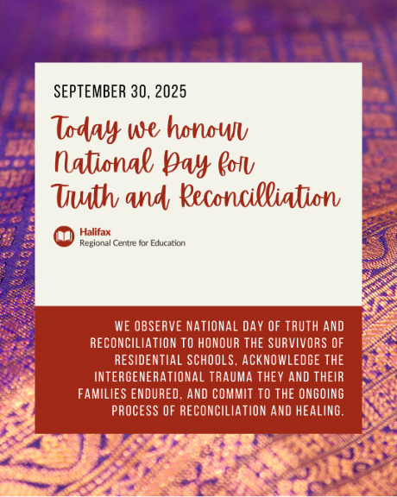

Demographic Form Updates
On September 9, the Demographic Updates Form will be available to families in the PowerSchool Parent Portal. This form should be updated by every family to ensure all information about your child is current, including contacts, medical information, consents and demographics. Even if there are no anticipated changes, please still review this information and submit the form. This information will then be reviewed by the school before updates are finalized. This deadline to submit the form is October 6, 2025.

