**Saint Mary’s Elementary School**

# **May 2025 Newsletter**

Dear SMES Families,

Happy May!Spring is in full bloom—and so is the learning at Saint Mary’s! From sprouting seeds to hatching chicks, butterflies, and even mystery eggs, our classrooms are bursting with discovery. This month is filled with special events, trips and activities, so please take note of the important dates.

I’m very happy to announce that I will be returning to Saint Mary’s as *Acting Principal* for the 2025-26 school year! I’m grateful for the opportunity to serve this incredible community and look forward to another successful year!

Warmly,  
*Ms. Johnson*

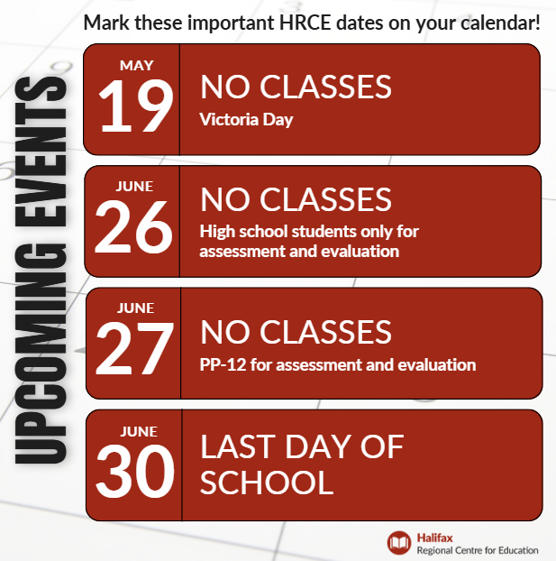**Important Dates**

* **May 2: Zelios & Corbin-Riley to Pier 21**
* **May 5: Participatory Budget Event, Central Library 6-8pm**
* **May 7: Kilby & Cyr to Pier 21**
* **May 8: Gorsebrook Trip Gr 6**

**Gorsebrook Parent Orientation**

* **May 9: Grade 5s & 6s to Pier 21**
  + **Toy Exchange (2-3pm)**
* **May 15: Black Excellence Day**
* **May 16: SuperNova @ SME**
* **May 19: No classes, Victoria Day**
* **May 20: Author Camilla Thompson visits**
* **May 23: Wanderers Trip Gr 5 & 6**
* **May 21: SAC Meeting @ 6:30pm via Teams**

**Life at Saint Mary’s**

* Pier 21 trips are scheduled for May 2, 7, and 9. Permission forms were sent home last week, and we’re working to secure chaperones.
* Chess Club is up and running! Students will participate in a provincial tournament in early May.
* Run Club started this week and will continue until the May long weekend. Track & Field tryouts and selections will take place this month; the Track Meet will be held in early June.
* SuperNova Science will visit all classes on May 16.
* Author Camilla Thompson will visit the upper grades on May 20.
* This month the Grade 3/4s will be hatching chicks, and the lower grades will watch caterpillars transforms into butterflies!
* Youth Engagement Coordinator, Scott Dillman, will be running a leadership program with some of our Grade 5s and 6s, they will be developing a project to support well-being and a sense of belonging for all students at Saint Mary’s! Stay tuned ☺

**Literacy and Math in Grade 3 Provincial Assessment**

Many of our Grade 3 students will be writing the Literacy and Math in Grade 3 Provincial Assessment on May 13, 14 and May 21 and 22. This is province-wide assessment that does not impact your child’s report card but helps the EECD, HRCE and our school gather important data on student achievement.

**Dragon’s Breath Toy Exchange May 5-9**

Darsh, a Grade 6 student, has been selected as a finalist for the Minister’s Entrepreneurship Award of Excellence! He will be running his project at Saint Mary’s next week (May 5–9). Students are encouraged to donate gently used toys (no stuffed toys unless they are new). We will collect them from May 5 to 7, and there will be a toy sale on May 9. All proceeds go to the school, and any unsold toys will be donated to the IWK.

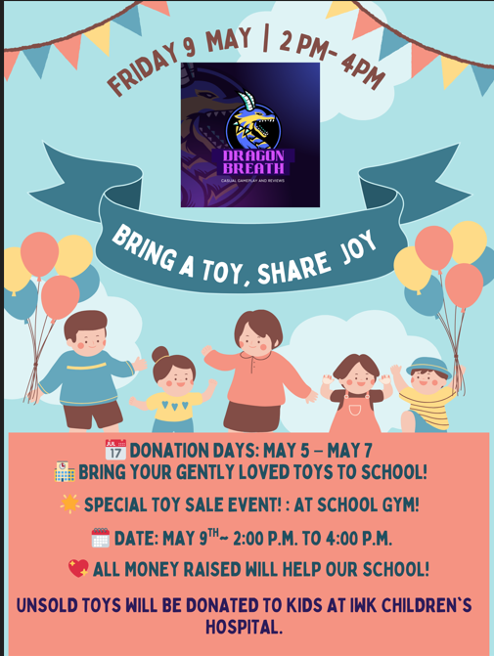

**Excel Registration**

The EXCEL Before and After Program is a recreation based, fee-for-service before and after school program run by Halifax Regional Centre for Education. At each school site where EXCEL is offered, the dedicated staffing teams plan games and activities that suit the needs and interests of all registered students. Since EXCEL began more than 25 years ago, staff have continually enhanced the program based on experiences and feedback. Today, with more than 4,000 participating students, EXCEL is one of the largest programs of its kind in the Maritimes, providing inclusive and engaging programming for participants.

For more information about registration, fees and programing, please [**click here**](https://www.hrce.ca/families/general-information/excel).

If you have additional questions, please contact the EXCEL Before and After Program Registrar’s Office: Kimberly Lozon at 902-464-2000 ext. 2787 or [excelregistrar@hrce.ca](mailto:excelregistrar@hrce.ca) and Gail Hartling at 902-464-2000 ext. 2236 or [excel@hrce.ca](mailto:excel@hrce.ca).

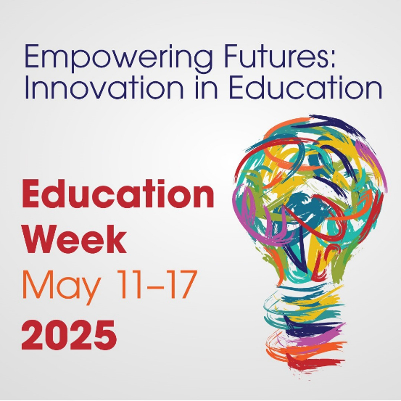**Education Week**

Education Week 2025, May 11 to 17, is a special opportunity to acknowledge educators, school support staff and partners for their outstanding work. This year’s theme, *Empowering Futures: Innovation in Education*, celebrates educators who have gone above and beyond in their efforts to infuse innovation into their classrooms and schools.

We applaud educators, school staff, and partners who embrace innovation in meeting the evolving needs of students in preparing them for a rapidly changing future.

Please take a moment, if you feel inspired, to send a note of appreciation to an educator in your child’s life who is having a positive impact!

**May 15 is Black Excellence Day**

What is Black Excellence Day? In essence Black Excellence Day is about acknowledging, celebrating, and uplifting Black contributions while fostering a more inclusive and equitable environment. The following are ways you celebrate the fourth annual Black Excellence Day:

**Celebrating achievements:** Black Excellence Day provides an opportunity to celebrate the achievements, contributions, and successes of Black individuals within the community. It highlights the talent and accomplishments within the Black community, ensuring that Black students have an opportunity to highlight all their positive contributions within the education system.

**Promoting equity and inclusion:** Recognizing Black Excellence fosters a culture of equity and inclusion within schools. It sends a message that all students, regardless of their background, have the potential to excel and make valuable contributions to society. By celebrating diversity and promoting inclusivity, schools create a more welcoming and supportive environment for all students.

**Education and awareness:** Black Excellence Day serves as an educational opportunity to raise awareness about the rich history, culture, and achievements of Black people. It provides a platform to share stories of resilience, innovation, and leadership, helping to combat stereotypes and promote understanding and appreciation of Black heritage.

**Empowerment and inspiration:** By celebrating Black Excellence, students are inspired and empowered to pursue their own goals and dreams. Seeing examples of successful Black individuals from various fields, such as science, arts, politics and sports, can motivate students to strive for their own excellence.

**Community engagement:** Black Excellence Day can serve as a platform for community engagement and collaboration. It provides an opportunity for schools to partner with local organizations, leaders, and activists within the Black community to organize events, workshops, and discussions that promote dialogue and understanding.

Overall, celebrating Black Excellence Day within HRCE schools is important for fostering a culture of inclusivity, empowerment, and appreciation for the diverse talents and contributions of Black individuals.   

**Homework Hub**

Did you know your student has access to Homework Hub? Finish the year off strong with the help of experienced tutors!

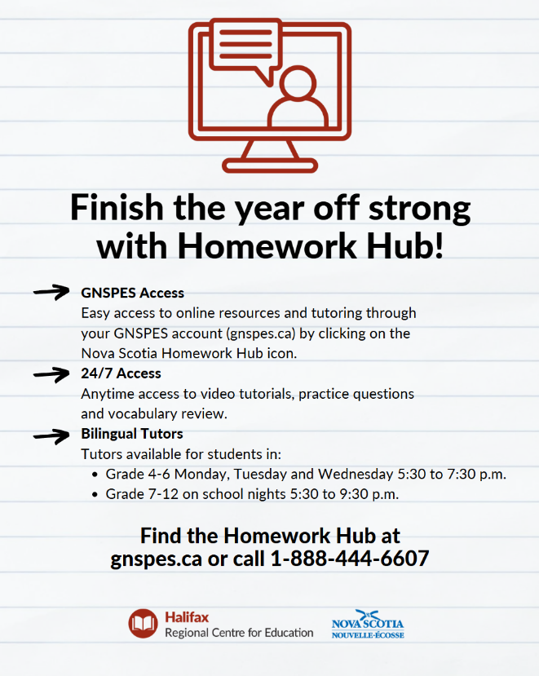·       **GNSPES Access:** Easy access to online resources and tutoring through your GNSPES account (gnspes.ca) by clicking on the Nova Scotia Homework Hub icon.

·       **24/7 Access:** Anytime access to video tutorials, practice questions and vocabulary review.

·       **Bilingual tutors available for students in:**

·       Grade 4-6 Monday, Tuesday and Wednesday 5:30 to 7:30 p.m.

·       Grade 7-12 on school nights 5:30 to 9:30 p.m.

[Watch this video](https://www.youtube.com/watch?v=YPzQU0LpQVs)

 to learn more about Homework Hub!

**Access Awareness Week**

Access Awareness Week takes place annually during the last week of May to raise awareness about disability, access and inclusion. This year, Access Awareness Week runs from May 25-31, and the provincial theme is "Our Voices, Our Votes: Disability Rights in Action.”

The provincial Accessibility Directorate is providing all HRCE schools with posters to help bring attention to the importance of removing barriers for people with disabilities. The posters are being mailed directly to schools from the directorate and should arrive in the coming days.

For 38 years, Nova Scotians have organized community events, flag raising, forums, and concerts during Access Awareness Week to bring attention to the importance of removing barriers for people with disabilities. More information can be found [here](https://nsleo.com/access-awareness-week-nova-scotia/).

