**Saint Mary’s Elementary School**

# **June 2025 Newsletter**

Hello Families!

And just like that, it’s June! As the school year wraps up, I want to thank you for the warm welcome I received when I joined the school community in January. It has been a privilege to get to know your children and work alongside such a supportive group of families and staff. I’m proud of all that our students have accomplished this year and excited to be returning in September to see their continued growth!

To our families of graduating students, congratulations! We are incredibly proud of your children and look forward to seeing the amazing things they will achieve in Junior High School and beyond! We look forward to celebrating with you at the Grade 6 Closing on June 23.

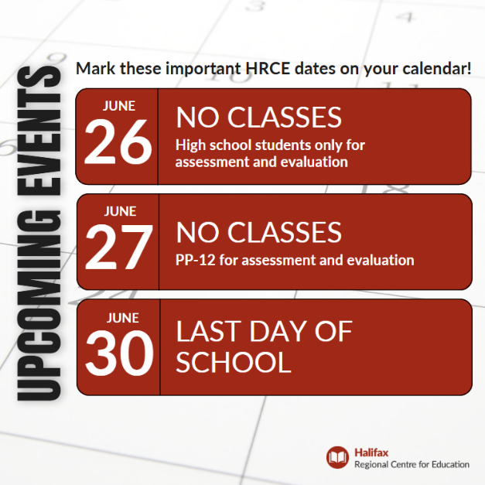We will be saying farewell to some of our beloved teachers this month and be welcoming some new teachers in September. I will keep you updated as staffing is confirmed later this month.

As always, reach out with any question you may have.

Wishing you all a happy final month of school!

Warmly,  
***Ms. Johnson***

**Important Dates**

* **June 2: Track & Field for Grade 6**
* **June 3: Track & Field for Grades 4 and 5**
* **June**

**Life at Saint Mary’s**

* The Chess Club participated in the Nova Scotia School Chess Tournament in May and our Grade 5 and 6 team finished in 4th place out of over 20 teams! Congratulations and thank you to Mr. C and Ms. Francis for running the club!
* Track & Field regionals take place on June 2 and 3. Selected students will be participating in running, jumping and throwing events.
* Fun Day
* Trips, trips, trips
* Talent Show & Violin showcase

**Safe Schools Strategy—Vision & Values Statement and Positive Behaviour Intervention and Support Marix**

In April, we met as a school staff to create a Vision & Values Statement and begin working on a Positive Behavior Intervention and Support Matrix. These tools will be launched in September 2025 as part of the Provincial Safe Schools Strategy and the new Code of Conduct. They will help us to create a safe and inclusive learning environment for all students.

We are looking for your feedback. Please take a minute to review the Statement and Matrix and provide your feedback using this [Vision & Values Statement and Matrix Feedback Form](https://forms.gle/iQ6hJEouwdiunvoL6)

**School Community Event—Saturday, June 14 from 10:00-11:30am**

Please join us!

**SAC Annual Report and Update**

The School Advisory Council (SAC) has been busy this year. Here are a few highlights:

* Supported the school in planning a trip to the Pier 21 Museum
* Discussed building connections with community organizations (Neptune Theatre, Natural History Museum, AGNS) for future programs
* Provided input on the Safe Schools Strategy, School Vision & Values, and Positive Behaviour Supports Matrix
* Participated in HRCE consultations and Thought Exchanges
* Discussed improvements to school grounds, including snow removal and interior cleanliness
* Engaged in meaningful conversations about the School Healthy Eating Program (food choices and safe handling practices)

**Are you interested in being a part of the SAC for the 2025-26 School Year? We will be looking for parents and community members to fill positions! Please reach out to Principal, Emily Johnson.**

**Excel is Hiring!**

Are you interested in working for the Before & After School program? These roles are a great fit for people with experience or interest in working with children, and include flexible hours, competitive pay, and the added benefit of free program access for the children of EXCEL staff while they are working. Please follow the link for more information: [Working with EXCEL 2025-26](https://forms.office.com/Pages/ResponsePage.aspx?id=lXjE3ZHjQUSeidBD16XaWFPWD3nlP2pIqL2moME2gQBUOU45TzVSUjJQWFJHQ1JaODlRVVQ3UlFLVi4u)

**Youth Engagement Project**

Education Week 2025, May 11 to 17, is a special

**Responsible Online Use**

**Homework Hub**

Did