**DECEMBER NEWSLETTER # 2**

Happy Holidays, Saint Mary’s Families! 

As we head into the holiday season and we take time to gather with family and friends, I want to take this opportunity to thank you for making me feel so welcome. I have such a soft spot for Saint Mary’s. That is because you have made me feel like family. I have enjoyed being your Acting Principal for the past four months. I will treasure the special bonds that I have made with your wonderful children. I hope to come back if ever I am needed.

Thank you.

Ms. Emily Johnson, your new Acting Principal, has been here many times over the last weeks to meet with me. She has met the staff and the students. She has even learned some of your children’s names! She is very excited to work with such a dynamic educational team and to be an integral part of ensuring that your children are safe, happy and learning.

Welcome, Ms. Johnson, I know you will love it here!

**Scholastic Book Fair **

Thank you to everyone who attended the Book Fair and supported our school with purchases. The Book Fair was a great success, and we were able to purchase many books for our library and for our classrooms. The SAC committee used some of it’s grant money and to give teachers an opportunity to purchase books to support literacy in the classroom.

Thank you, Ms. Olga for arranging all of this for us. We appreciate all of your hard work!

A FEW REMINDERS FOR THE NEW YEAR

**Drop and Go Parking Lot** 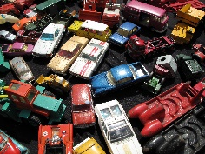

Thank you all for helping to make the parking lot a safer place for our students. Every morning, there are fewer cars trying to get up the driveway.

Please **do not** park your car in the driveway so that you can walk your child to the classroom door. This causes unnecessary congestion.

There is a teacher out on duty at 8:45 and every morning I stand on the sidewalk to ensure children are safely making their way to the school grounds.

**We are a ‘DROP AND GO’ parking lot.**

**Cold Weather **

As we experience the colder weather, we encourage you to send your children to school dressed for the chilly, wet weather. Hats, mittens, gloves, warm jackets, snow pants and boots are necessary now. Your children are out for half an hour at lunch and for 15-minute breaks throughout the day.

**Getting to School on Time**

Thank you to all the students who arrive on time in the morning! We appreciate the effort you are making to get here!

Students go into the building at ***8:55***. Classes begin at ***9:00***. If students arrive after 9:00, their attendance is marked as late. They also miss valuable instructional time and disrupt the learning of others.

I would like to see everyone arrive at school in time to line up with your class in the morning! You can do this!!

**Upcoming Dates**

  Friday, December 20 Last day of school for 2024

Thursday, January 2 First day of 2025 for staff

Friday, January 3 First day of 2025 for students

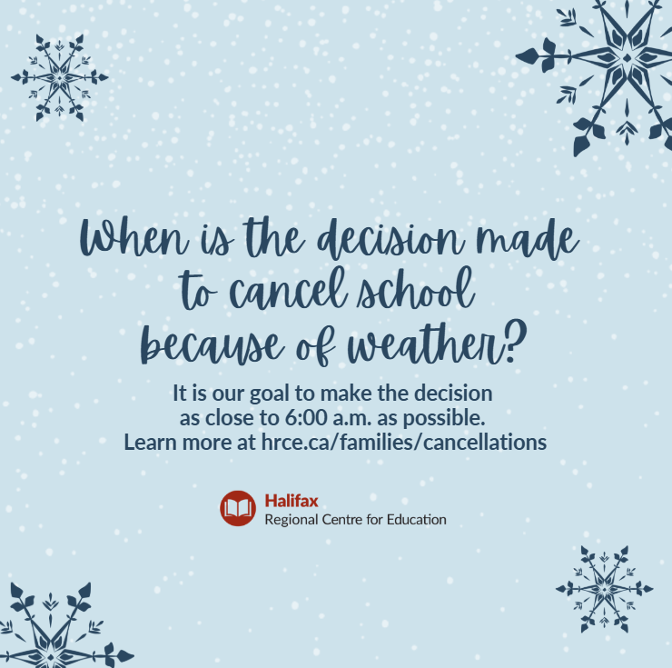

**Important weather reminders** 

Did you know? HRCE takes great care when making the decision to alter the regular operations of schools and school busses in the event of severe or inclement weather.   

It is HRCE’s goal to communicate any changes to the regular operations of schools and/or buses as close to 6:00 a.m. as possible. **A 6:00 a.m. announcement could be:**

* All schools are delayed in opening by two hours and bus pickups are delayed by two hours; or
* All schools are open, but some or all busses are not operating for the day; or
* Some schools (either individually or by family) are closed for the day; or
* All schools are closed for the day.

If weather deteriorates, or is forecasted to worsen throughout the morning, **an 11:00 a.m. announcement could be:**

* Bused students will be picked up two hours earlier than their regular dismissal time; and
* Non-bused students will be dismissed at their regularly scheduled lunch hour.

**How will I find out?**

* By email to the addresses in PowerSchool
* By text message, **if you have opted-in**. If you aren’t sure if you have opted-in, text Y to the following number: **978338**
* On [our website](https://www.hrce.ca/)
* On [X (formerly Twitter)](https://twitter.com/HRCE_NS)
* On [Instagram](https://www.instagram.com/hrce_ns/)

It’s important to always have a plan in place for childcare in the event of any cancellation.

For more information on how HRCE manages during inclement weather, visit www.hrce.ca/families/cancellations.