**DECEMBER NEWSLETTER**

Happy December, Saint Mary Families!

**Cold Weather**

As we head into the colder months, we encourage you to send your children to school dressed for the chilly weather. Hats, mittens, gloves, warm jackets and boots are necessary now. Your children are out for half an hour at lunch and for 15-minute breaks throughout the day.

**Early to School**

Thank you to all the students who arrive on time in the morning! We appreciate the effort you are making to get here!

Students go into the building at ***8:55***. Classes begin at ***9:00***. If students arrive after 9:00, their attendance is marked as late. They also miss valuable instructional time and disrupt the learning of others.

I would like to see everyone arrive at school in time to line up with your class in the morning! You can do this!!

**School Parking Lot Safety**

I am very pleased to see so many families and students walking to school!

If you must drive up the driveway, please **stop**, let your **child** **out** of the car and **leave**. Consider having your child sit on the passenger side so they can get out safely onto the sidewalk. Do not park your car and walk your child to the school yard. If you must walk your child to the yard, ***do not*** drive into the parking lot. *Park on the street and walk up.* The driveway is too small to accommodate all the cars that are presently using it.

Thank you for your continued support in keeping our students safe.

**Provincial Lunch Program** 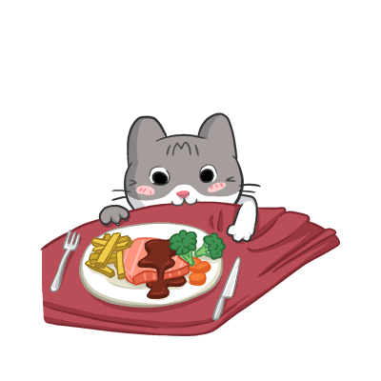

The lunch program has gone through some growing pains as it has begun. The vendor for Saint Mary’s is now in place and we are happy that the lunches are always on time, and they stay hot. If you haven’t ordered yet, please check it out novascotialunch.ca. The vendors are required to follow strict healthy eating guidelines, and the portion sizes are also controlled by guidelines set down by the province. I am ordering extra lunches every day. If your child still feels hungry after they have had their lunch, they can come to the office and receive one of the extra lunches.

School lunches can now be ordered for December 9 to December 20. Order at https://hrce.nslunch.ca

**Scholastic Book Fair **

For the first time in several years, our school will be hosting a Scholastic Book Fair. This will be held in the gymnasium. There will be an opportunity for students to visit the book fair display with their classes. Parents will have an opportunity to visit the book fair during the parent/guardian/teacher interviews on the evening of December 4th from 5:00 to 7:00 and the afternoon of December 5th  from 1:00 to 3:00.

Thank you, Ms. Olga for arranging all of this for us.

**Holiday Concert **

The Holiday Concert will take place on Monday, December 2nd at 6:00 in the evening. Students should arrive at 5:30.

Each family has received two tickets. Only people with a ticket will be allowed in. If you require extra tickets, please let the office know. Thank you to Ms Wilson and the students for all your hard work in preparing the songs for the concert.

**Upcoming Dates **

Monday, December 2 Holiday Concert – 6:00

Students arrive at 5:30

Tuesday, December 3 Report Cards emailed home

Tuesday, December 3 Scholastic Book Fair Set Up

Wednesday, December 4 Progress Conferences

5:00 to 7:00

*Book Fair open for family members*

Thursday, December 5 PD/Parent Teacher – **no school for students**

Progress Conferences

1:00 to 3:00

*Book Fair open for family members*

Friday, December 6 Book Fair – last day to make purchases

Friday, December 20 Last Day of School before our holiday break